**Initial Analysis Result: Storm Water Discharge Safety Report for CT**

**Data Cleaning and Formatting:**

The data was available in two excel files. One file recorded information from 1995 – 2012 and the other more updated file recorded information from 2011 – 2014. The newer data had all the industries classified into 12 broad sectors. We intended to use this classification, and hence both the data were made compatible through thorough data cleaning and formatting. We used SIC codes to identify and map industries to sectors. Some of the SIC codes from the old file did not match any from the newer data so, temporarily we have left those out and went on with our analysis.

Project Goal 1:

How are the nutrients and sediments pollutant levels declining over time? Is TSS decreasing at a faster rate than nutrients?

Actions:

We provide graphical exploratory analysis results. LOESS method was applied to produce smooth non-parametric plots for each of the nutrients and the sediments over time. The plots allow us to study the behavior of the overall data through time. We do not plot individual points, as it is quite impossible to discern any pattern looking at the data due to presence of quite a few outliers.

For Reference we list the sectors and the numbers that represent them:

|  |  |
| --- | --- |
| Sector | Number |
| General and Sec-G Transport | 1 |
| A - Asphalt | 2 |
| B – Mines & Quartz | 3 |
| C - Refuse | 4 |
| D – Auto Sal | 5 |
| E – Scrap Recycling | 6 |
| F – Steam Gen | 7 |
| G – Small Air | 8 |
| G – Muni & Fed | 9 |
| G - DOT | 10 |
| H – Marina & Boat | 11 |
| I – Ship Building & Repair | 12 |

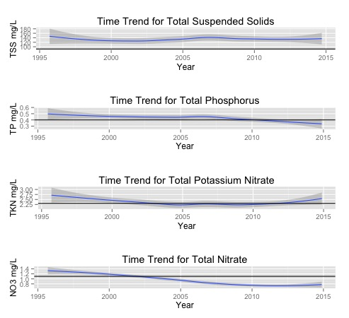

Observation:

* Total phosphorus (TP) and total Nitrate (NO3) pollutant loadings exhibits a decreasing trends, dipping below the new benchmarks
* Total Suspended Solids (TSS) shows more or less a constant trend during the past years, however we cannot claim from the plots that it is decreasing.
* Total potassium nitrate (TKN) shows increasing trends in recent past, after exhibiting stable constant trend in the first decade of 2000.

We are also going to look at the trends of each nutrient and pollutant over all industrial sectors.

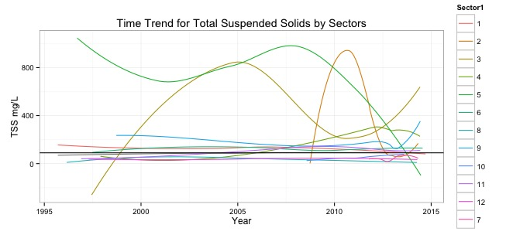

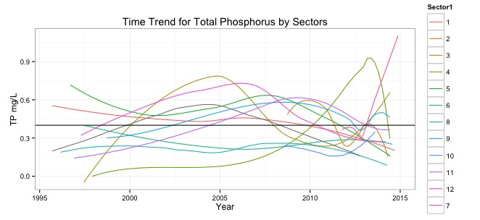

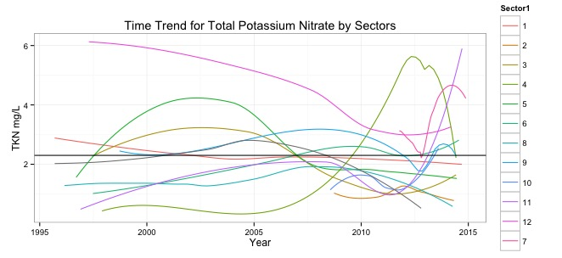

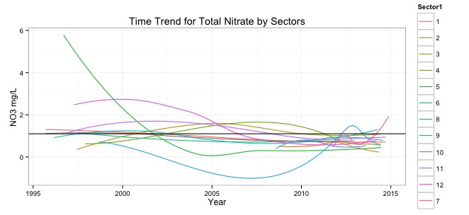

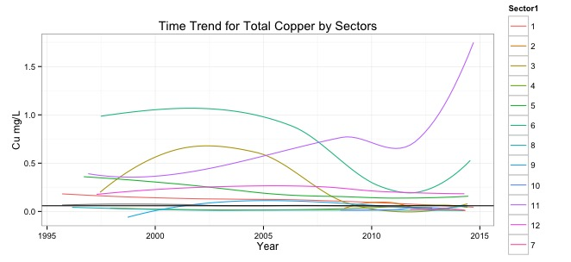

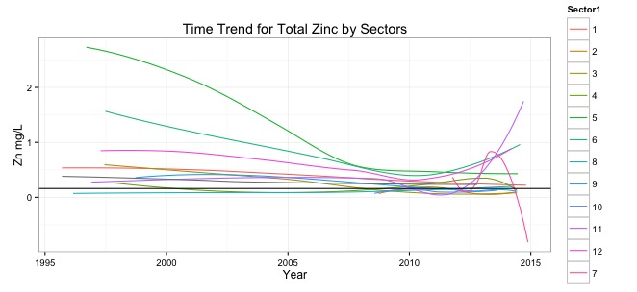

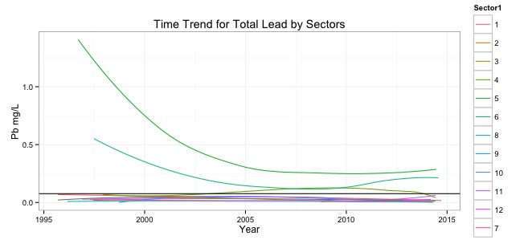

Observation:

* Total suspended solids (TSS) exhibit sharp decreasing trend for Sector 5, Sectors 2, 3, 4, 9 and 7 show increasing trends.
* Total Nitrates (NO3): Only Sector 7 shows increasing trend in recent times
* Total Potassium Nitrates (TKN), Sectors 7, 11, 12 and 8 exhibit increasing trends. Sector 4 after increasing from 2005 – 2012, now shows a steep decrease.
* Total Phosphorus (TP), Sector 7, 3 shows sharp increasing trends, Sector 11, although below limit, is on the rise. Sector 4 exhibits similar behavior wr.t. TP as with TKN.
* Total zinc (Zn), sectors 6, 11 and 12 are the only ones with increasing trends. Sector 7 shows a sharp decrease.
* Total copper (Cu), sectors 11, 6 and 3 shows increasing trends.
* Total lead (Pb), sectors 5 and 6 are the only ones above the benchmark.

Conclusion:

* Your suggestions/conclusions/remarks after the analyses

SAS RESULTS:

List of SAS Graphs and Tables you want to provide to the client.

QUESTIONS/DOUBTS:

* Doubts/Issues you have faced during the initial analysis